**Ryan Robinson’s Freelance Contract Template**

Brought to you by: [Ryan Robinson](https://www.ryrob.com/)

Real quick before grabbing and using this contract template!

If you haven’t read my full post on [what a solid freelance contract should include](https://www.ryrob.com/freelance-contract/), I highly recommend finishing that post before implementing this template with any of your clients.

***Disclaimer:*** This template is the copy & paste starting point I use for each new client relationship, but small customizations are made based upon the specifics of each agreement.

While this is a great template to hit the ground running with (and has been used in my business for many years), my lawyer wants me to tell you that I am not an attorney and this should not be taken as legal advice. I cannot be held liable for any ramifications of your use of this template.

If you have the ability to get a quick consultation with an attorney to get a stamp of approval on *your version* of a freelance contract (for your own unique situations, needs, and area of residence) I recommend doing that.

And if you want to take your freelance contract game to the next level, I highly recommend signing up for [**a free 14 day trial with my friends over Bonsai Contracts**](https://www.ryrob.com/resources/bonsai-contracts/).

***The contract template starts on page 2…***

To make a copy of this document so you can save it to your own Google Drive and edit, go to:

File → Make a copy… and save a version of this document to your own Google Drive.

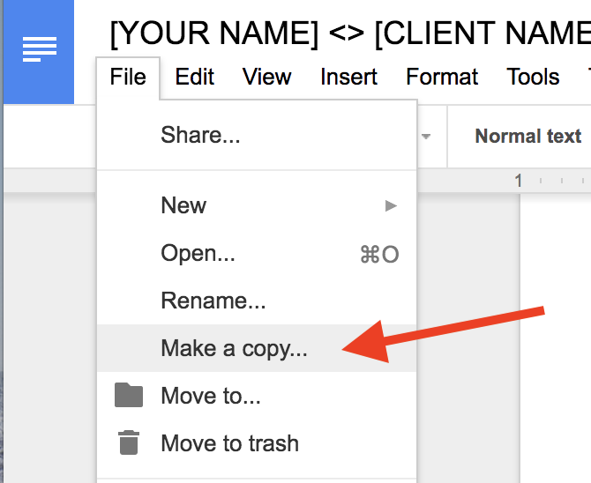

From there, you’ll be able to make *private* revisions, save and start sending to clients. 😊

***[YOUR NAME]* <> [CLIENT NAME]**

**Contractor Agreement**

***[YOUR NAME]*** (also known as “Contractor”) will provide **[CLIENT, Inc.]** (also known as “Client”) with [INSERT SHORT OVERVIEW OF YOUR DELIVERABLES ~ 1 SENTENCE] as to the specifications detailed in the Terms and Conditions below.

**Contract in effect beginning:** [TODAY’S DATE]

**Terms and Conditions**

The following rates and terms apply:

Client will pay **[$X,XXX]** to Contractor via direct deposit, PayPal, credit card, or other electronic payment processor as agreed to by both parties, no later than the 7th of the month, for work delivered and accepted in the previous month.

Contractor will provide the following as per deliverable dates and content topics mutually agreed upon:

* [DELIVERABLE #1 and ANY RELEVANT SPECIFICATIONS OR DUE DATES]
* [DELIVERABLE #2 and ANY RELEVANT SPECIFICATIONS OR DUE DATES]
* [DELIVERABLE #3 and ANY RELEVANT SPECIFICATIONS OR DUE DATES]

**Scope of Project**

Contractor is [SERVICE YOU’RE PERFORMING] for Client. Contractor agrees to perform services until the engagement has ended.

**Changes and Revisions**

The price at the beginning of this contract is based on the time investment I estimate is needed to accomplish everything you’ve told me you want to achieve with [YOUR DELIVERABLES], but I’m happy to be flexible. If you want to change our arrangement or add anything new, I’ll provide a separate estimate for that.

**Legal**

I can’t guarantee that my work will be completely error-free and so I can’t be liable to you or any third-party for damages, including lost profits, lost savings or other incidental, consequential or special damages, even if you’ve advised me of them. If any provision of this contract shall be unlawful, void, or for any reason unenforceable, then that provision shall be deemed severable from this contract and shall not affect the validity and enforceability of any remaining provisions.

**Copyright**

Client will own the copyright for all material created under this agreement, and contractor can showcase sample works from this project as portfolio pieces only with consent and approval from client.

**Payment**

Contractor will invoice client on the last business day of each month, for [DELIVERABLE] delivered/accepted that month. Payment shall be completed by client in the amount of **[$X,XXX]** to contractor no later than the 7th of the following month, for work delivered/accepted in the previous month.

**Termination**

This agreement may be terminated with 15 days written notice by either party.

|  |  |
| --- | --- |
| ***Client agrees to terms and policies specified above:***    *Signature: ____________________________*  *Name & Title: _________________________*  *Date: _________________________________* | ***Accepted by the Contractor:***  *[Signature Goes Here]*  *Your Name*  *Date* |